United Way of MPM and NiSource Increase Capacity of Area Food Pantries
United Way of Muskingum, Perry, and Morgan Counties Funds $20,000 to Muskingum County Food Pantries through NiSource Charitable Foundation grant

Zanesville, Ohio March 23, 2023 – United Way of Muskingum, Perry, and Morgan Counties (UWMPM) strives to reduce food insecurity by increasing access to food for our community members. The Supplemental Nutrition Assistance Program (SNAP) and other public assistance programs are being restored back to pre-pandemic levels. To make certain community members have access to food, UWMPM is partnering with NiSource/Columbia Gas Foundation to invest $20,000 to build capacity of area food pantries. The initial payment will be utilized to guarantee food pantries are stocked for community members. Remaining funds will purchase food vouchers to be distributed through several community partner organizations.
Meg Deedrick, UWMPM Executive Director, states, “Along with our community partners, United Way of MPM has been monitoring the impact of pandemic resources and resources needed for the transition to pre-pandemic levels since July 2021. We are extremely grateful for our partnership with Columbia Gas/NiSource which has enabled us to direct additional financial resources to meet the needs of our friends and neighbors.”
UWMPM has the capacity to fund this initiative through the NiSource Charitable Foundation, Columbia Gas. NiSource provides funding for non-profit organizations that help create strong and sustainable communities. NiSource’s areas of giving include, safety, economic & workforce development, environmental stewardship, STEM and energy education, and basic needs & hardship assistance. UWMPM is very grateful for this partnership and the opportunity to continue to serve our community.
Stephanie Merkle, Columbia Gas of Ohio Community Engagement Manger, states, “At Columbia Gas, we are dedicated to helping provide basic needs to those who need it most. Our perspective is shaped by the connection between utilities and food, and we believe both are basic human needs. We’re proud to partner with United Way of Muskingum, Morgan, and Perry Counites to limit food restrictions while increasing access to fresh and nutritious foods throughout the area. So many of our neighbors don’t know where their next meal will come from – a fact that should be unacceptable to all of us.”
Keely Warden, Muskingum County Hunger Network Executive Committee Member, states, “Everyone involved with the Muskingum County Hunger Network is so very grateful for the emergency support being invested with us from the United Way of Muskingum, Perry, and Morgan Counties. The extra SNAP benefits that were given to families during the Covid pandemic ended at end of February. We are not sure what the future will hold for the individuals and families we serve but the Network will be here to help. It is reassuring to know that community partners, such as the United Way, are aware and ready to take care of our community. Knowing the Muskingum County Hunger Network could face food shortages our local United Way was first in asking “How can we help?” Everyone involved with our Hunger Network extends a huge thank you to our local United Way.”
To access Muskingum County food pantries, dial 2-1-1 or visit www.unitedwayofmpm.org. Also, on the website you can donate to help fight for the health, education, and financial stability of every person in every community!

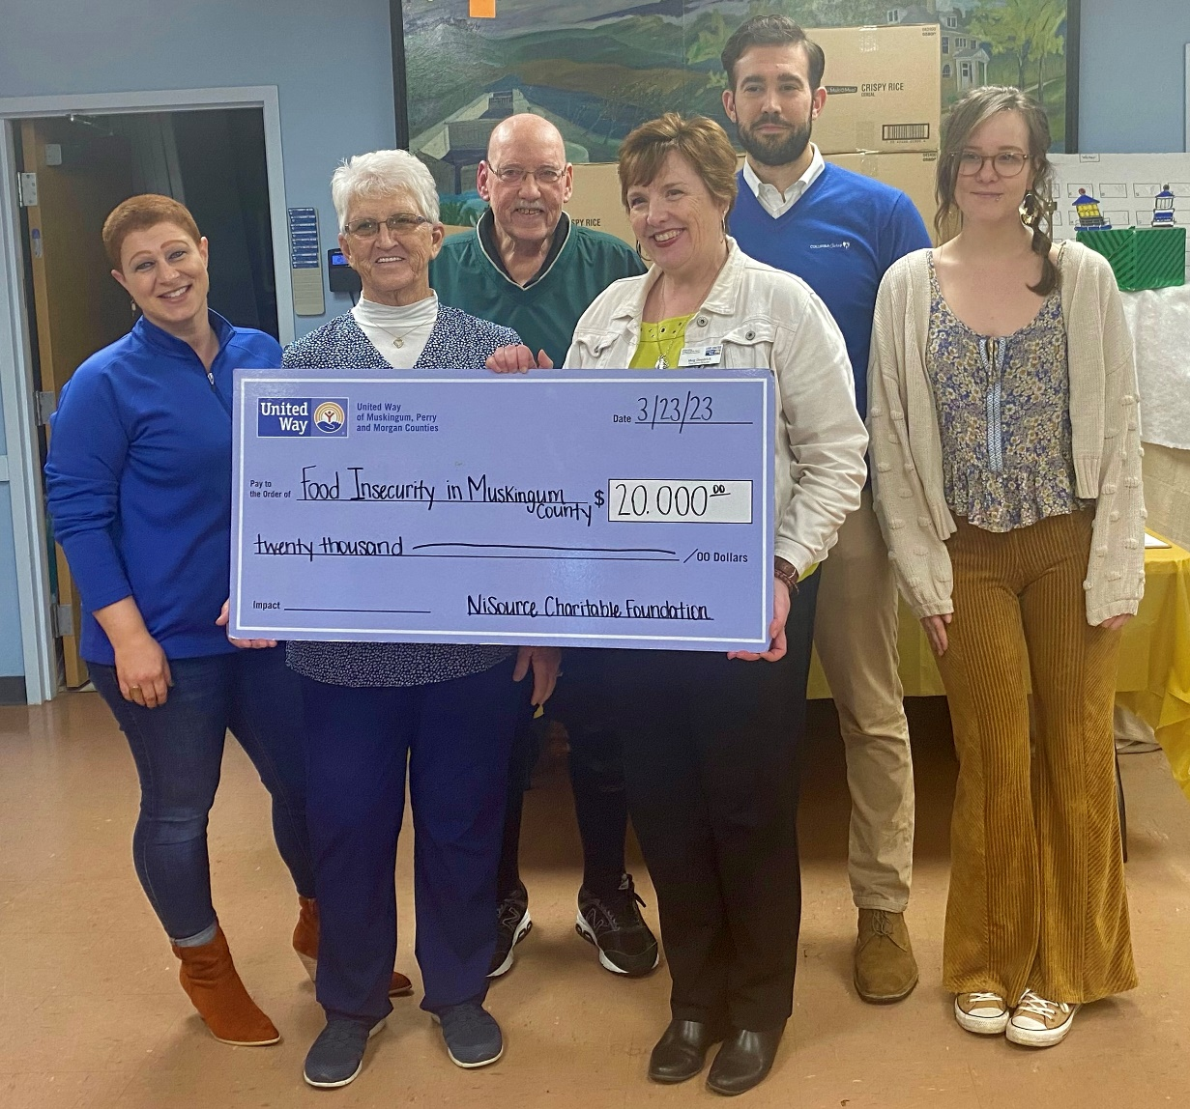
About United Way of Muskingum, Perry, and Morgan Counties: Since 1954 UWMPM has empowered local people to make the most of what they have through outcome-based initiatives, and investment in local programs. UWMPM’s focus is on improving the health, education, and financial stability of every person in all our communities. If you would like to donate, volunteer, or apply for funding, please call 740-454-6872, or visit unitedwayofmpm.org.

