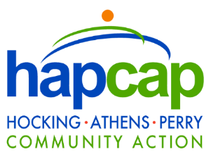

PRESS RELEASE
TO: ALL MEDIA
DATE: 5/26/2021
LOCATION: PERRY COUNTY, OHIO
CONTACT: CLAIRE GYSEGEM, PUBLIC RELATIONS MANAGER
HOCKING ATHENS PERRY COMMUNITY ACTION
CLAIRE.GYSEGEM@HAPCAP.ORG | (740) 767-4500

NON-PROFITS COLLABORATING IN PERRY COUNTY
Local Community Action and United Way agencies working together on pandemic-related programs
NEW LEXINGTON, OH – This spring, two organizations teamed up to provide resources to Perry County Residents.
Hocking Athens Perry Community Action (HAPCAP) partnered with United Way of Muskingum, Perry, and Morgan counties to distribute over 100 COVID-19 Wellness Bags to residents in Perry County. The bags held an assortment of personal protective equipment, personal hygiene items, and tools to assist in coping with the ongoing pandemic. The bags also contained printed information on vaccination and self-care resources.
“We understand that this has been a tough year on all of us and our hope is that we can continue to provide resources to our Perry County families,” says Clarissa Reynolds, HAPCAP’s Perry County Community Resource Navigator. “We are grateful to the United Way’s Community Investment Fund for providing us the opportunity to help the residents in Perry County.”
HAPCAP also provides a variety of programs to assist Perry County residents, ranging from child development to housing needs. Assistance is available for rent, mortgage, water and other utilities, and HAPCAP’s Corning and New Lexington Head Start Centers are actively recruiting families for free preschool services. HAPCAP is also the parent organization of the Southeast Ohio Foodbank. A list of Perry County member food pantries is available at hapcap.org.
For more information on HAPCAP’s programs, please contact Clarissa Reynolds via email at clarissa.reynolds@hapcap.org, or at (740) 342-4113.
For information on the United Way of Muskingum, Perry and Morgan Counties, please visit www.unitedwayofmpm.org.
# # #

