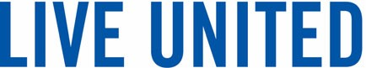

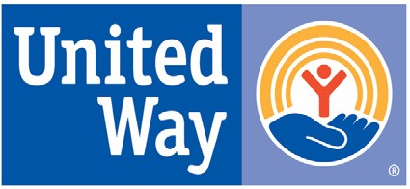

For Immediate Release: 3/9/21
For more information, contact Meg Deedrick, Executive Director
mdeedrick@unitedwayofmpm.org

Park National Bank Fuels United Way’s Community Empowerment Efforts Again

Zanesville, Ohio Park National Bank has announced their United Way of Muskingum Perry and Morgan Counties (UWMPM) fundraising Campaign total of $74,926.58. UWMPM will invest this money in local programs and initiatives that promote health, education, and financial stability.

The funds from Park National Bank come from 3 sources.
• Employee Payroll deduction – Employees donate a portion each paycheck to UWMPM over the course of the year.
• Corporate donation – Park National Bank determines a total amount that bank will donate each year.
• Internal Fundraisers – Dedicated volunteers set up and operate creative fundraisers such as raffles, auctions, etc.

Tori White, of Park National Bank explained their fundraising effort: “Despite the challenges of 2020 we were able to shift the focus of our fundraisers to accommodate both those working in the office and from home. We are proud of the results--our employees are truly dedicated to giving back to the communities we serve.”

“Park came through once again. The employees came through by supporting the United Way and because of their investment in us we were able to meet the needs that we anticipated and those we couldn’t have dreamed of at this time last year.” - Meg Deedrick UWMPM Executive Director

UWMPM looks for to using the funds raised in the next year to both continue to support safety net programs and focus on empowerment programs and activities – programs that promote health, education, and financial stability for people who are not necessarily in need of emergency support.

Some empowerment activities UWMPM will support and provide include: financial literacy courses, home cooking education, tax preparation assistance, and more.

About United Way of Muskingum, Perry and Morgan Counties: Since 1954 UWMPM has empowered local people to make the most of what they have through outcome based initiatives, and investment in local programs. UWMPM’s focus is on improving the health, education, and financial stability of every person in all our communities. If you would like to donate, volunteer, or apply for funding, please call 740-454-6872, or visit unitedwayofmpm.org.

GIVE. ADVOCATE. VOLUNTEER.
Advancing Education, Income, and Health

United Way of Muskingum, Perry, and Morgan Counties
526 Putnam Avenue Zanesville, Ohio 43701 740‐454‐6872 www.unitedwayofmpm.org

